
A14
Sreenidhi Institute of Science & Technology
(An Autonomous Institution)
Code No: 4Q110
M. TECH. I – Year I – Semester Examinations, March/April 2015, (Regular)
ENGINEERING MATHEMATICS (BT)

Time: 3 Hours Max. Marks: 60

Note: No additional answer sheets will be provided.

Part - A
Max.Marks:10

Answer all QUESTIONS.

1. Find the value of 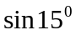

2. Define continuity of a function.
3. If z=f(u) where 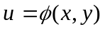 then 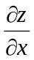
4. Find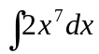
5. Find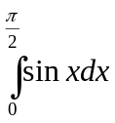
6. Eliminate c from 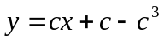
7. 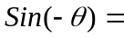
8. If 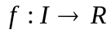is differentiable on the internal I, then find 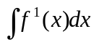
9. 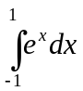
10. Find general solution of 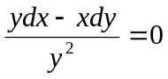

Part – B
Max. Marks: 50
ANSWER ANY FIVE QUESTIONS. EACH QUESTION CARRIES 10 MARKS.

1 (a) Show that 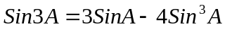

(b) If Sinhx=3/4, find cosh(2x) and sinh(2x)

2 (a) Find the first order partial derivatives of 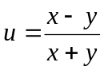

(b) If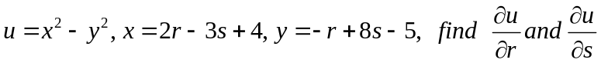

3 (a) If 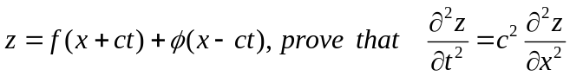

(b) If 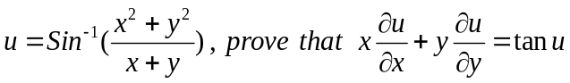

4 (a) Evaluate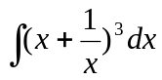

(b) Evaluate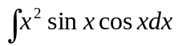

5 (a) Find 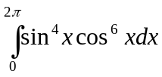

(b) Find the area lying between the parabola 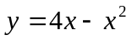 and the line y=x .

6 (a) Solve 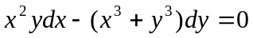

(b) Solve 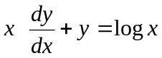

7 (a) Solve 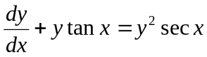

(b) Find the area cut off between the line y=0 and the parabola 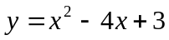

-- 00 -- 00 --

